**Chapter 3**

**System Design**

**3.1 Block Diagram**

The block diagram in Figure shows that the power supply is useful for activating the Arduino Mega 2560 and also the water level sensor. This water level sensor uses a sensor strip connected to the transistor switch as an indicator of water level and becomes the data input for Arduino Mega 2560. After the data is input the data will be sent with a WIFI signal to the thingspeak page and the water level display on the runway can be accessed using a PC that is far from the runway. The mechanical design of the water level sensing shown in Figure

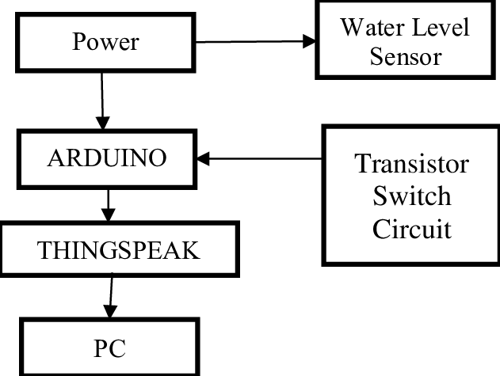

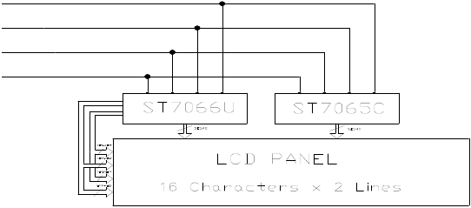

**3.2 Circuit Diagram**

**circuit diagram** represents a **water level monitoring system** that uses a combination of a **microcontroller (or decoder IC), sensors, an LCD display, and an alert system**. Below is a detailed analysis of the different sections of the circuit.

**3.2.1 Water Level Sensors Section**

* The left side of the diagram shows multiple **water level probes** labeled **20%, 40%, 60%, 80%, and 100%**.
* These sensors (possibly metallic probes or conductive plates) detect the water level and send signals to the main processing unit.
* The circuit likely works by checking whether the probes are submerged in water, completing an electrical circuit and generating a signal.

**3.2.2 Microcontroller/IC (Main Processing Unit)**

* The central rectangular block appears to be a **microcontroller or a multiplexer/decoder IC** that takes inputs from the **water level sensors**.
* **Pins labeled A0, A1, A2, A3, A4, and A5** suggest that these are address lines used for selecting input signals.
* It processes the input from the sensors and sends corresponding outputs to the **LCD display**.

**3.2.3. LCD Display (16x2) for Water Level Indication**

* A **16x2 LCD module (with RS, E, D4-D7 pins labeled)** is used to display the **current water level percentage**.
* The microcontroller sends the processed data to the display, showing levels like **"Water Level: 40%"** or **"Tank Full"**.
* **Resistors (4.7KΩ)** are used for **pull-up/pull-down** connections to ensure proper signal transmission.

**3.2.4. Transistor (BC547) with LED Alert System**

* A **BC547 NPN transistor** is connected with a **resistor (1KΩ)** and an **LED**.
* This part of the circuit serves as an **alarm/indicator mechanism**, turning ON the LED when the tank is **full or empty**.
* The transistor acts as a **switch**, allowing current to flow through the LED when triggered.
* A **battery is used as the power source** for this alert system
* 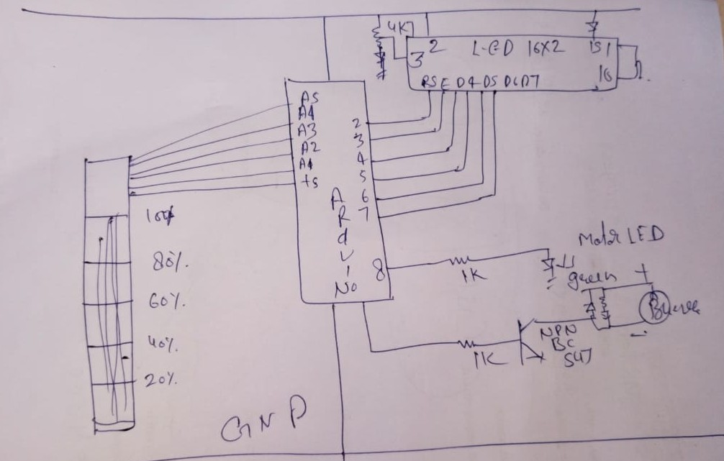

This diagram represents a **Water Level Monitoring and Control System** using **Arduino** and **ThingSpeak** (an IoT platform). Here's a breakdown of how it works:

**🔌 Power Supply**

* **Power** is supplied to the components in the system — particularly the **Water Level Sensor** and **Arduino**.

**💧 Water Level Sensor**

* The **Water Level Sensor** detects the water level in a tank or reservoir.
* It sends signals (analog or digital) to the **Arduino** to indicate the level.

**🧠 Arduino**

* The **Arduino** acts as the central microcontroller.
* It receives sensor data, processes it, and performs two main tasks:
  + Sends the data to **ThingSpeak** for online monitoring.
  + Activates or deactivates the **Transistor Switch Circuit** to control a pump or another device.

**⚙️ Transistor Switch Circuit**

* Acts like a relay or electronic switch.
* Controlled by Arduino to **turn ON/OFF a pump or motor** based on water level.
* Ensures automation in the water refilling or draining process.

**☁️ ThingSpeak (IoT Platform)**

* Receives data from the Arduino.
* Visualizes it in charts or graphs online.
* Can be used for **remote monitoring**, **data logging**, and **alerts**.

**🖥️ PC**

* Used to access the **ThingSpeak dashboard** for monitoring the water level.
* Can also be used for programming and configuring the Arduino.